# Class Diagram

# The class diagram represents the different classes that has been identified for the project. The classes are main, donations, members, fund and reports. The diagram shows the relationships among the classes.

# 

# Class Diagram

## **E and R Diagram**

It is the database model which shows the entities (tables) that will be used in the project database. It shows the relationships between tables via primary key and foreign key.

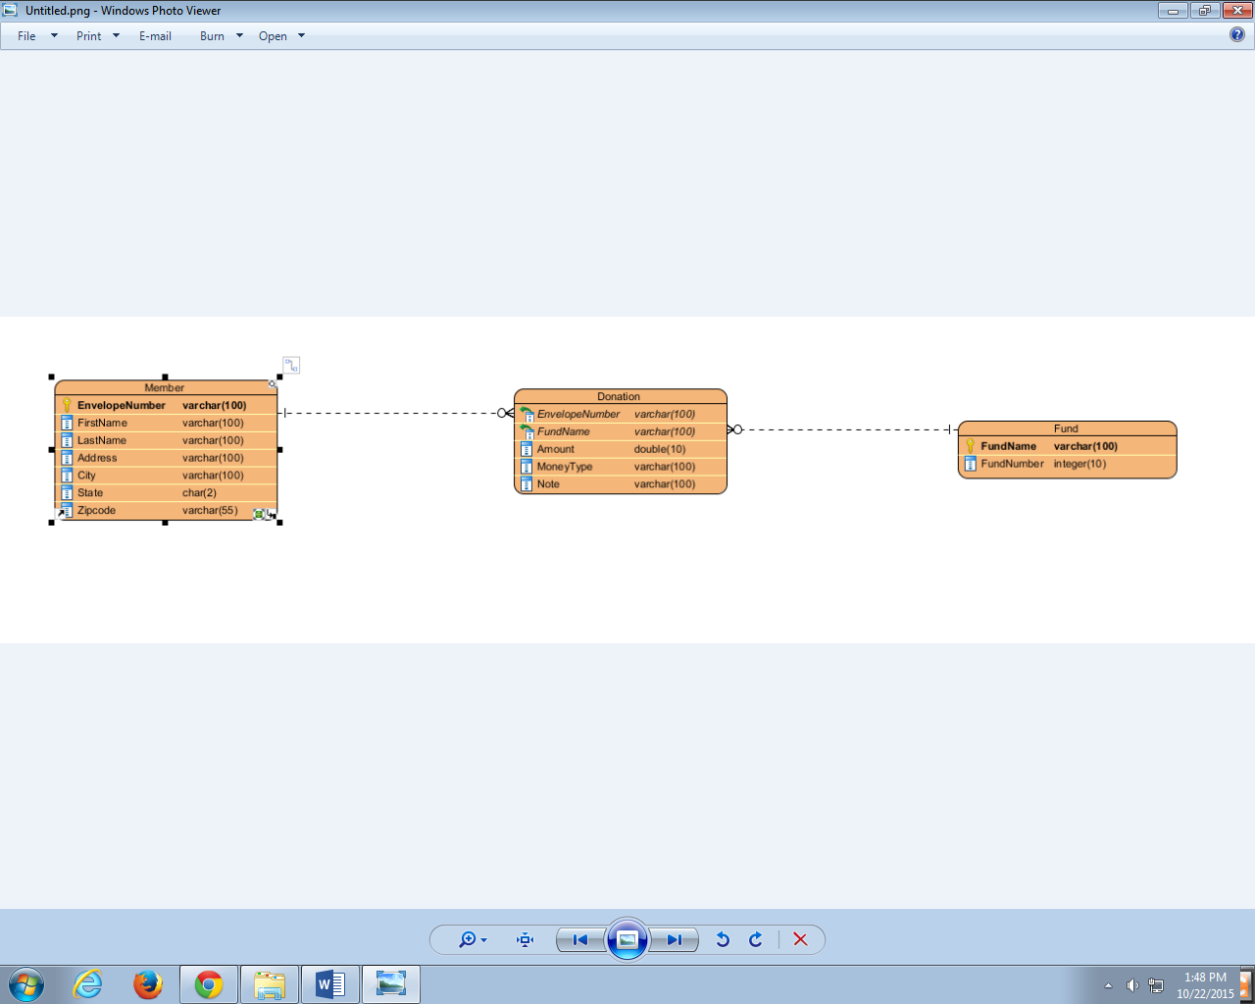

E and R Diagram